**Question 1: Constructing a DFA for Language using Kleene Closure (**(𝑎𝑏)∗𝑎(𝑏𝑎)**)* and Positive Closure (**(𝑎𝑏)∗𝑎(𝑏𝑎)**)+**

**Language** : Design a deterministic finite automaton (DFA) for the language described by the regular expression (𝑎𝑏)∗𝑎(𝑏𝑎) . The DFA should accept any string that consists of zero or more repetitions of the substring "ab", followed by 'a', and ending with one or more repetitions of the substring "ba". Provide the state diagram and the transition table for the DFA.

**Solution:**

Formal language and rules are defined in question. Utilize rules mentioned below to construct DFA

1. (ab)∗: Zero or more repetitions of the substring "ab".
2. a: A single 'a'.
3. (ba)+ One or more repetitions of the substring "ba".

Now list down valid strings such as

1. ababa
2. abababa
3. ababababa

Now construct DFA of any string using following structure

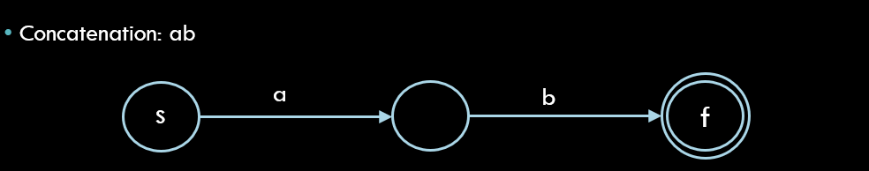

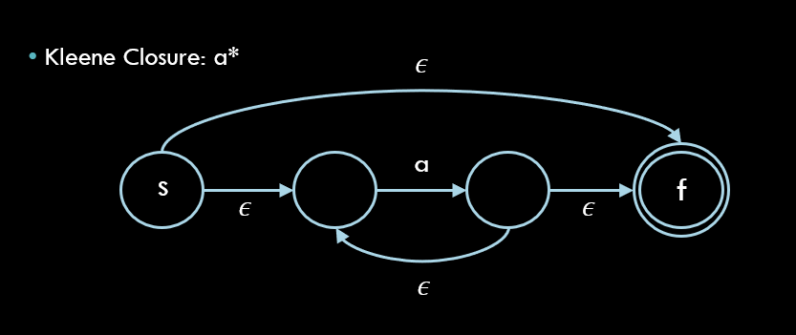

Grading criteria :

Student’s solution should reflect the following core concepts of CC and DFA

1. Interpretation of language and rules
2. Implementation of rules to design valid strings
3. Apply concatenation , parallelism and closure rules in DFA.